Quick Guide to Writing Effective Working Papers
Mini Guides |
A working paper is commonly a precursor to a Draft Resolution. It is a place to put the first draft of the ideas that you hope to guide to the resolution through lobbying, negotiation and compromise. However, just because a working paper needs to turn into a draft resolution does not mean that it has to be formatted like one from the get go. The time that is used to find appropriate preambulatory or operative phrases or proper formatting and punctuation, could be better used to convey important ideas to many other delegates in a less formal manner. This can be especially useful in the early stages of the writing process. The following guide will give you some tips on how to better utilize the working paper stage and make yours much easier to understand and your lobbying time much more effective.

Bold or highlight important words and sentences
In the lobby rush of unmoderated caucuses many delegates won’t have the time to read the entire working paper. As you and your block will often find yourselves repeating the same pitch to different delegates. It is very helpful to be able to point to key words and sentences and help them stand out.

Use maps and graphs
As a working paper is not a formal document, feel free to use a map when explain troop movement or where you would set up a medical camp. When explaining your idea to other delegate you would need to load a map on your computer or smartphone anyway, so better to have the map or chart ready to make you idea clear and ready to understand.
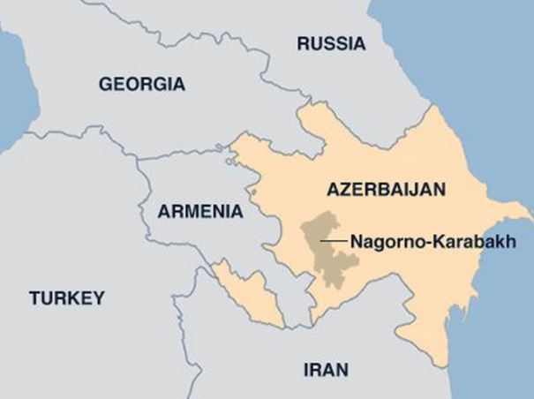
Pointing to the region, showing proximity to borders and neighbors can do a better job than explaining the region in generalizations even if it takes five times the time.

Use Equations
More food aid + Training of teenagers to cook = less idle hands in refugee camps
Sometimes writing out the variables / stakeholders in an equation like the one above can be more clear than an entire paragraph. Use an equation to establish your main idea in way that shows clear cause and effect. Even when you have clauses written later on in the process you can keep your equation on the top of the draft. With the draft in hand you can tell others that they are welcome to read further but your main idea is here in the math on the top of the page.

Copy chunks of raw data
Sometimes your operative clauses will need specific names and data. While the specific clause may use some of the data, when speaking to potential signatories showing the whole picture may turn out better. For yourself you can highlight the main points but also show supporting data which will help you persuade but isn’t relevant enough to reach the final operative clause

Mix Preambulatory and Operative
One of the requirements of good chairs is that all operative clauses are justified by preambulatory clauses which elaborate on the problem that the operative clauses are solving. Sometimes, when writing operative clauses on our own we forget the preamb we were going to match with them. When explaining working papers to other delegates writing the clause in a ‘problem - solution’ manner might be very helpful to get your idea across.

Don’t write too much
Some resolution writers feel clauses need to be very long and cumbersome or they should not be submitted. On the other hand, early stage working papers are there to transfer ideas. Writing one line per idea to be developed later can help you lobby with 5 people in the time it would take to develop a clause and the subsequent sub clauses. Follow the KISS rule (Keep It Short and Simple), especially when it’s an early stage working paper.

Use headlines
Every few clauses use a headline so the reader will understand what issue the clauses are dealing with. Using headlines like “Regulations Pertaining to Peacekeeping Forces”, “United Nations-Facilitated Disarmament Oversight and Initiatives” and “Humanitarian Assistance and Funding Initiatives” will make the resolution a much easier and clearer read.

Have a cheat sheet
Especially useful in larger room, if the resolution is being modified by writers lobbyists can use a cheat sheet one pager with bullet points of the main ideas. The headlines from tip 7 could be useful for this. Using a cheat sheet to keep up the ideas will let you do what you were doing anyway in a more clear manner.

Give options where you can
Working papers are about persuasion and negotiation. Naturally, some policies will not be set in stone. If you find ideas that can be solved in multiple similar ways, write both options and have it open for discussion.
Example:
- Develop a cure for a virus internally at the UN
- Outsource the job to independent researchers
Asking opinions can get other delegates to feel more invested. On the other hand, if many delegates feel strongly about both you may have an issue.

Request Comments
Many working papers are written in google docs. Another way to get maximal input quickly is to give instructions to other delegates to leave comments. You can do this with instructions in the document, sharing with the “Can view” option or even yelling across the room. You will find that some positive suggestions, and the openness to do so, could not only bring you new allies but also new ideas.

Conclusion
These 10 tips above will not only make your working paper clearer but are also faster to write. It is true that the same principles behind a United Nations resolution often exist for working papers as well. These principles are also helpful when giving speeches and in general when learning to think MUN. At the same time, working papers are not draft resolutions and there is no law requiring you to make them perfectly formatted or legally sound, especially so early in the process. In fact, the opposite often occurs where the rush to format results in you scrolling through a working paper to find clause 15, which no one will read and you need to spend extra time understanding what you are reading before you read it. Using even some of these tips will make your working paper more easy to understand and will help your allies get signatories or defend it against the opposition. The key is to keep in mind that a draft resolution needs to have a majority to pass and getting that majority starts when they understand the ideas you will show them in a clear working paper.

Making the Most of Working Papers in Model UN
by nicholas on November 12, 2014
Working Papers, commonly precursors to Draft Resolutions, aren’t really given the attention they should be in committee. At most conferences I’ve been to they are simply a convenient way to introduce draft resolutions without worrying about sponsors or resolution formatting – and that’s a shame.
The flexibility you are allowed in introducing working papers, and the fact that it’s easier to introduce than a draft resolution, make these some very potent tools. Here’s a list of ways to really get the best bang for your buck:
1. Depth, not length
Everyone loves introducing long working papers, but when you have multiple blocs trying to introduce papers that run up to two or three pages, nobody is honestly going to read (and remember) all of it.
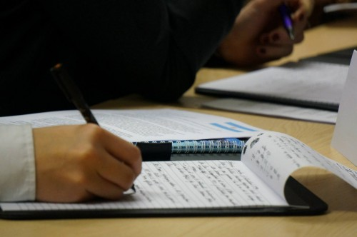
To stand out, don’t think length – think quality. Many of the working papers that come out fast are either cobbled together quickly to try and cover as much of the topic as possible, or were pre-written (which isn’t ideal).
So rather than have a long list of short, scrambled clauses, why not put more time and effort into just two or three really standout ones? Flesh out the nuances and words just right, get your terminology correct, throw in some appropriate technical terms and jargon and you’ll have a well-developed working paper that people can actually take the time to read and pay attention to!
That’s when the other delegates in the room start approaching you; by looking like you know how to draft really competent clauses, people will want you working with them – or at the very least they’ll want to steal your clauses for their own. But no matter. The credit belongs to you, and everyone saw you write it first.
2. Play around with the format
The other thing most delegates don’t seem to notice or care about with position papers is that they can be almost anything – they don’t have to be anything like draft resolutions!
In most cases, you can submit plenty of other things as working papers – like reports, graphs and images. The point is that it enables delegates to introduce media for the committee to consider, and which will aid them in discussion. It is much easier to move debate forward when everyone knows exactly what the report you referenced in your speech contains.
Be cautious with this, however. Remember that your chairs still have to approve your working paper, so this isn’t to be used as a gimmick – what you introduce should legitimately get delegates to think. It could be an infographic cataloguing state contributions to climate change. Or it could be an innovative think-tank proposal. Either way, if it’s something useful which wasn’t in the study guide, you’ll stand out for having done something different and something useful. First-time delegates in particular will be grateful.
3. Time them well
Once the draft resolutions begin rolling out, everyone forgets about working papers. But it doesn’t mean you cannot introduce them any more.
The amendments-dominated phase of MUN committees are perhaps the most hectic – everyone is trying to get their ideas in and shape the draft resolution before time runs out. Substantial clauses are sometimes voted on without a great deal of debate, and it can be difficult to properly defend (or criticise) some clauses with just one stab at speaking.
Working papers, when deployed correctly here, can do a lot to help. By being illustrative it gets a point across in a way that might otherwise be lost when delegates rely on short speeches alone.
Of course, this is something to be used very sparingly – time is limited, after all, and chairs will prioritise amendments over working papers. But if you can introduce something truly pertinent and helpful, then you come out ahead.
Timing is important in the early stages of committee, too. The working paper that gets submitted first gets vetted first, and in all likelihood introduced first. By being the first one out of the gate you get everyone’s attention – and if yours is a compelling one, the next unmoderated caucus will begin to centre around you. If on the other hand you take too much time writing a long working paper, you may find yourself in line behind four or five others.
These are just a few of the ways working papers can be an effective tool for debate in committee. They are vastly underrated, and any delegate looking for fresh ways to distinguish themselves ought to plan ahead and use these to their advantage.
Of course, none of this will make up for weak content and tired ideas. Remember that at the end of the day this isn’t a shortcut to success – it is a tool that bolsters a good idea and helps the committee.

